**Capacitance-Based Fingerprint Sensor**

Dissanayake D.M.M.L.  *Department of Electrial and Electronic Engineering  
University of Peradeniya*  
Peradeniya, Sri Lanka [e21109@eng.pdn.ac.lk](mailto:e21109@eng.pdn.ac.lk)

Firdous M.T. *Department of Electrial and Electronic Engineering  
University of Peradeniya*  
Peradeniya, Sri Lanka [e21139@eng.pdn.ac.lk](mailto:e21139@eng.pdn.ac.lk)

Samarakoon S.M.O.T. *Department of Electrial and Electronic Engineering  
University of Peradeniya*  
Peradeniya, Sri Lanka [e21345@eng.pdn.ac.lk](mailto:e21345@eng.pdn.ac.lk)

***Abstract*—This project is designed to study the behavior of a variable capacitor by analyzing the voltage response of a simple RC circuit. The circuit consists of a resistor connected in series with a parallel-plate capacitor, and the capacitance is varied by adjusting the distance between two copper-plated boards. These boards are mounted on formboards at discrete heights and connected using crocodile clips. A 20 V amplitude input signal is applied through a high-pass filter that filters out frequencies below 339 Hz. The setup allows for observing the change in voltage across the resistor for each discrete capacitance value. This experiment helps in understanding the effect of plate separation on capacitance and signal behavior in AC circuits.**

***Keywords* - Capacitive sensor, High-Pass filter, Resistor-Capacitor Circuit**

1. Introduction

Fingerprint recognition is a widely used biometric identification technology due to its reliability, ease of use, and fast authentication capabilities. Over time, fingerprint sensing has evolved from traditional ink-based methods to advanced technologies such as optical, capacitive, and ultrasonic systems, enabling its integration into mobile devices, security systems, and identity verification processes. This paper presents a capacitance-based fingerprint sensor designed to accurately distinguish between the unique ridge and valley patterns of a fingerprint, ensuring precise detection of its physical structure

During the development phase, several alternative methods were explored. Ultrasonic sensing, which captures a 3D model by analyzing reflected sound waves from the fingerprint surface, was ruled out due to its high cost and complexity. Photodiode-based sensing was also considered; however, spatial limitations prevented the integration of a sufficient number of photodiodes without an expensive array, resulting in low accuracy. Optical fingerprint recognition, which relies on reflected light patterns from a fingertip placed on a glass surface, was similarly deemed impractical, as achieving the correct angle of reflection using IR LEDs added unnecessary complexity. Given these challenges, the capacitance-based approach was selected. A capacitive fingerprint sensor uses a capacitive sensor array to detect fingerprints. The name ‘capacitive’ comes from the fact that the finger skin and the sensor electrode produce a capacitor whose capacitance is determined by the distance from the chip surface to the finger skin.[1]

The approximate capacitance of parallel-plate capacitors is derived in simple electrostatics for the case in which the electric charge density on the plates is uniform and the fringing fields at the edges can be neglected. [2]

1. Initial specifications
2. *Measurement quality*

This sensor is applicable for air or any suitable dielectric medium. The sensor can be affected by external Electro-Magnetic interferences.

1. *Range*

The range of the sensor spans from 0.5cm to 2.5cm. The range can be increased by changing the medium to a different medium with a higher relative dielectric constant. (Polyester, Ceramic, Glass)

1. *Resolution*

In this sensor to get a significant output voltage difference, the height difference needed or resolution was 0.1 cm.

1. *Other specifications*
   * Operating Frequency: 100 kHz
   * High-Pass Cutoff Frequency: 339 Hz
   * Operating Voltage: 20 V (peak)
   * Error: ± 0.05 cm
   * Area of Grounded copper plate: 4 cm × 2.1 cm = 8.4 cm²
   * Area of variable copper plate: 5 cm × 3.5 cm = 16.5 cm²
   * Intersecting Area of the Capacitor: 4 cm × 2.1 cm = 8.4 cm²
   * Dielectric medium: Air (**ε =** 8.859 × 10⁻¹² F/m**)**
2. METHOD

As mentioned in the introduction, the method of this sensor design is the capacitive-based approach.

1. *Principle of operation*

The method used in this sensor involves creating discrete height values using box-shaped objects made from foam. These foam structures are designed to be non-conductive. For each height level, copper plates are attached to the insides of the different foam layers. One of the plates, referred to as the "eye," serves as the ground reference and is connected to the ground. This setup effectively forms a variable capacitor, where the distance between the copper plates changes with the height, altering the capacitance. To minimize interference, particularly the 50 Hz noise commonly present in electrical circuits, a passive high-pass filter is employed. This filter consists of a capacitor and resistor arranged in series. The filter's cutoff frequency is   chosen to eliminate the 50 Hz

component while allowing the higher frequency signal to pass. The input voltage applied to the circuit is a 20 V peak signal at 100 kHz. This high frequency was selected due to the low capacitance of the setup, which results in high impedance at lower frequencies. Using a higher frequency ensures that the capacitive reactance, given by 1/jωC​, is small enough to allow

measurable current flow.

*B. Circuit Diagram*

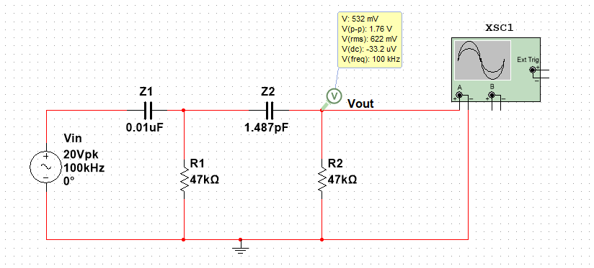

Fig. 1. Circuit diagram

In this circuit diagram $Z_{1}$ is the impedance of the $C_{1}$ capacitor,

Also $Z_{2}$ is taken when d = 0.5cm,

$$V_{out}=\frac{R_{1}.R_{2}.V_{in }}{\left(R_{1}+R_{2}+Z_{1}\right)+\frac{d}{Ajωε}}$$

*C. Calibration Process*

To measure the sensor's response, an oscilloscope is connected across the resistor. The output voltage across the resistor is then observed for different discrete height values. The capacitance C is inversely proportional to the distance (d) between the two plates, following the formula:

C $=\frac{Aε}{d}$

As the distance between plates increases, the capacitance decreases, which in turn affects the impedance of the capacitor. Since the capacitor and resistor are in series, any change in capacitance alters the total impedance of the circuit. This variation influences the current through the circuit and thus changes the voltage drop across the resistor.

By recording the output voltage across the resistor for each known height, a relationship between output voltage and height can be established. These values are then used to construct a calibration curve, which maps voltage readings to specific height levels. This curve enables the sensor to accurately determine height based on the output voltage in practical applications.

*D. Sensor Module*

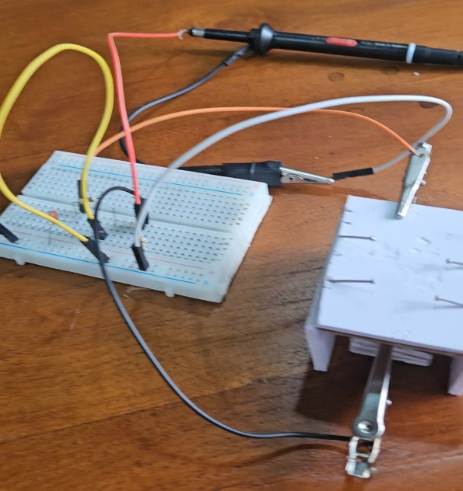

Fig. 2. Experimental Setup of the Sensor

The figure above shows the setup with a 20-volt (100kHz) input supplied to the circuit via a signal generator. The output voltage across the series resistor is measured using an oscilloscope.

1. *Statistical analysis*

Averages and Standard deviations are calculated according to the readings in Table II.

⬧ - Standard deviation

*xi* - Voltage reading

𝑥̅ - Average

*n* - No. of readings

TABLE I. AVERAGES AND STANDARD DEVIATION OF OUTPUT VOLTAGE

|  |  |  |
| --- | --- | --- |
| **Distance**  **(cm)** | **Average voltage (mV)** | **Standard deviation**  **(mV)** |
| 0.5 | 942.0 | 14.02 |
| 0.6 | 890.0 | 14.88 |
| 0.7 | 828.8 | 12.31 |
| 0.8 | 796.3 | 14.05 |
| 1.0 | 707.4 | 6.47 |
| 1.2 | 647.6 | 10.83 |
| 1.5 | 607.6 | 7.83 |
| 1.8 | 565.8 | 15.56 |

1. *Calibration Curve*

Based on both theoretical modeling and curve fitting from measured data, the relationship between output voltage ( $V_{out}$, in mV) and distance (h, in cm) was best modeled by the inverse function:

$$V_{out}=\frac{A}{Bh+C}$$

1. $V_{out}$: Output voltage
2. h     : Height between capacitor plate
3. A:   70840.3588        B:    42.3284          C:  54.9725

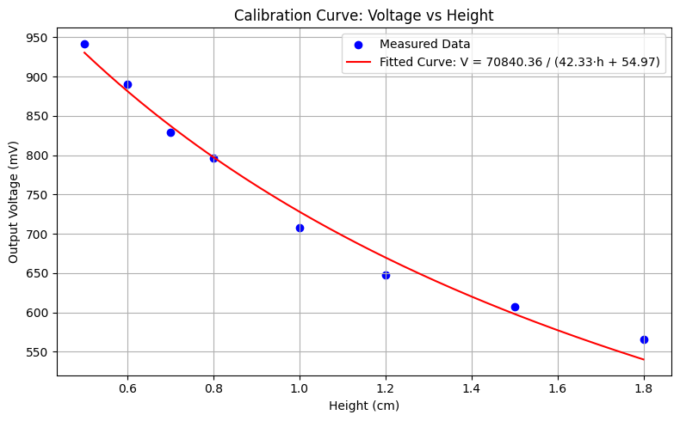

  Fig. 3. Voltage VS Height Curve for Measured Data

The sensor’s output exhibits a strong inverse relationship with height. The calibration curve shows a very high correlation (R² = 0.9851), validating the use of the model $V_{out}=\frac{A}{Bh+C}$ for further analysis and measurement conversions.[3]

1. *Sensitivity*

$Sensitivity(h) =S(h)=\frac{dV_{out}}{dh}$

S(h) = $\frac{d}{dh}\left(\frac{A}{Bh+C}\right)$ = - $\frac{AB}{(Bh+C)²}$

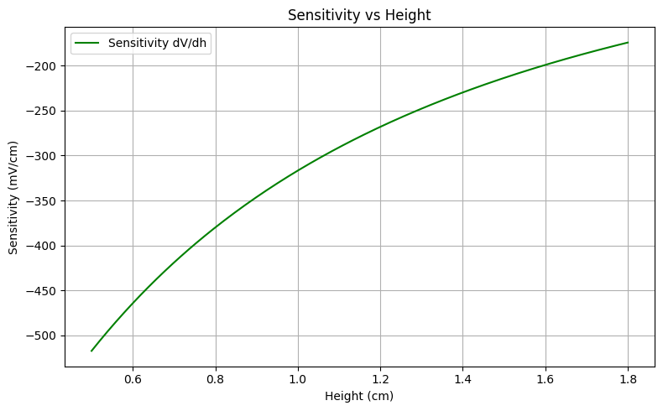

Fig. 4. Sensitivity VS Height of Fitted Model For Sensor

TABLE II. MEASURED SENSITIVITY

|  |  |
| --- | --- |
| **Distance(cm)** | **Average output voltage (mV)** |
| ≈ 0.55 | -580.00 |
| ≈ 0.65 | -612.00 |
| ≈ 0.75 | -325.00 |
| ≈ 0.90 | -444.50 |
| ≈ 1.10 | -299.00 |
| ≈ 1.35 | -133.33 |
| ≈ 1.65 | -139.33 |

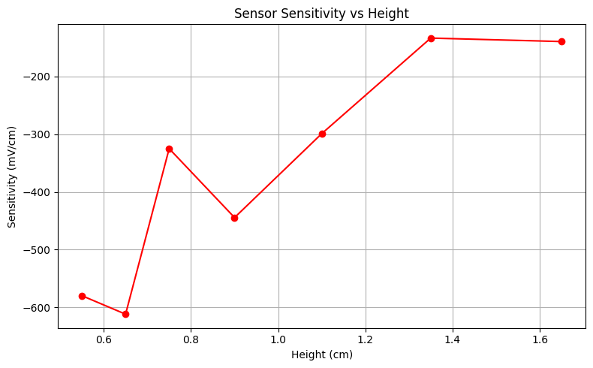

Fig. 5. Sensor Sensitivity VS Height Using Measured Data

Sensitivity decreases with height due to the inverse relationship.

Theoretically when approaches infinity sensitivity goes to zero, but practically when h>=2.5cm, the variation of $V_{out}$ is negligible.

Peak sensitivity occurs at the smallest measurable distance.

The sensor exhibits non-uniform sensitivity, peaking in the range of 0.6 cm and diminishing beyond 1.2 cm. Both theoretical and experimental sensitivity analyses confirm that the sensor is highly sensitive in the near-field region. The theoretical sensitivity curve closely aligns with empirical results, reinforcing the validity of the model**.**

1. *Hysteresis*

Hysteresis is the difference in sensor output when the same input (height) is approached from different directions — in this case, ascending vs descending. Or in other words, the mean difference between ascending and descending at the same height.

Hysteresis(h) = | (h)- $V_{ascending}$ (h)|

Hysteresis Error (%) = $\frac{Hysteresis\left(h\right)}{Vmax-Vmin}$ x 100%

TABLE III. AVERAGE DESCENDIN & ASCENDING VOLTAGE VALUES

|  |  |  |
| --- | --- | --- |
| **Height(cm)** | **Average Voltage(mV)** | |
| **Descending** | **Ascending** |
| 0.5 | 954.0 | 942.0 |
| 0.6 | 902.2 | 877.8 |
| 0.7 | 838.6 | 819.0 |
| 0.8 | 808.2 | 784.4 |
| 1.0 | 711.6 | 703.2 |
| 1.2 | 655.0 | 640.2 |
| 1.5 | 613.8 | 601.4 |
| 1.8 | 579.2 | 552.4 |

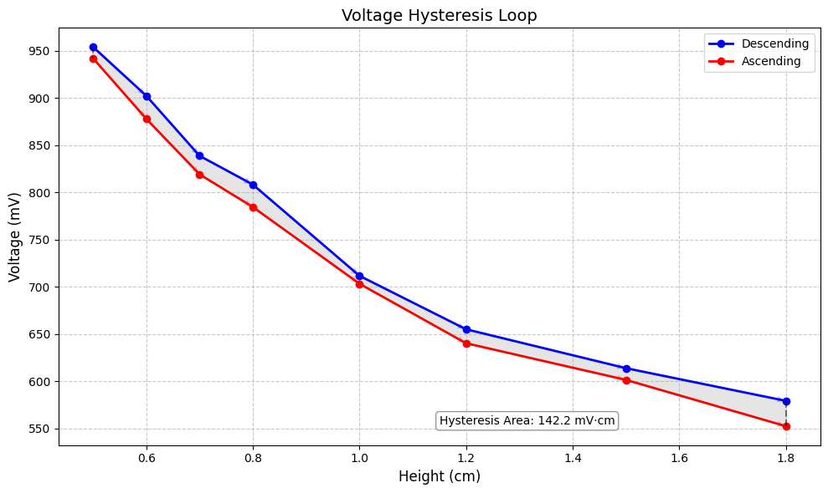

Fig. 6. Voltage Hysteresis loop

TABLE IV. HYSTERESIS ERROR

|  |  |
| --- | --- |
| **Height (cm)** | **Hysteresis Error (%)** |
| 0.5 | 2.99 |
| 0.6 | 6.08 |
| 0.7 | 4.88 |
| 0.8 | 5.93 |
| 1.0 | 2.09 |
| 1.2 | 3.69 |
| 1.5 | 3.09 |
| 1.8 | 6.67 |

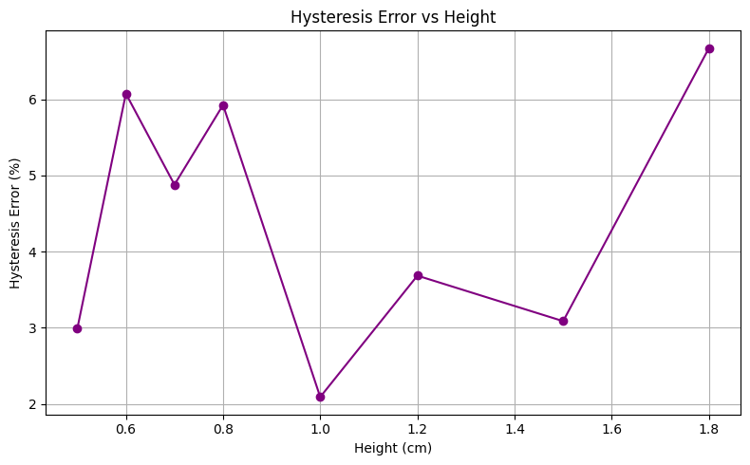

Fig. 7. Hysteresis Error VS Height

Therefore, it can be observed that the sensor exhibits hysteresis across the entire height range, with maximum error reaching 6.67% at 1.8 cm. The loop area of 142.2 mV·cm represents the energy loss or non-ideality in measurement behavior. The sensor is most consistent and reliable in the mid-range (~1.0–1.5 cm), where hysteresis error is minimized.

*D. Resolution*

The empirical resolution of the sensor, based on the smallest height interval used in measurements, is 0.1 cm (1 mm). This assumes that the corresponding voltage change at this scale exceeds the detection limit (noise level) of the system. Over the operational range of 0.5 cm to 1.8 cm, this resolution remains constant in step size, though actual voltage response varies due to sensor non-linearity.

In this Sensor, the $V_{out}$-Height relationship is non-linear.

* At low heights, small changes in height cause big changes in voltage (high sensitivity → better resolution).
* At high heights, same height change causes smaller voltage change (low sensitivity → worse resolution)

$$Resolution =\frac{∆V}{|S(h)|}$$

$∆V →$ uncertainty in measured voltage

$S(h)→$ the sensitivity at height h

TABLE V.-RESOLUTION VS HEIGHT

|  |  |
| --- | --- |
| **Height (cm)** | **Resolution (cm)** |
| 0.5 | 0.0086 |
| 0.6 | 0.0101 |
| 0.7 | 0.0093 |
| 0.8 | 0.0117 |
| 1.0 | 0.0065 |
| 1.2 | 0.0128 |
| 1.5 | 0.0116 |
| 1.8 | 0.0282 |

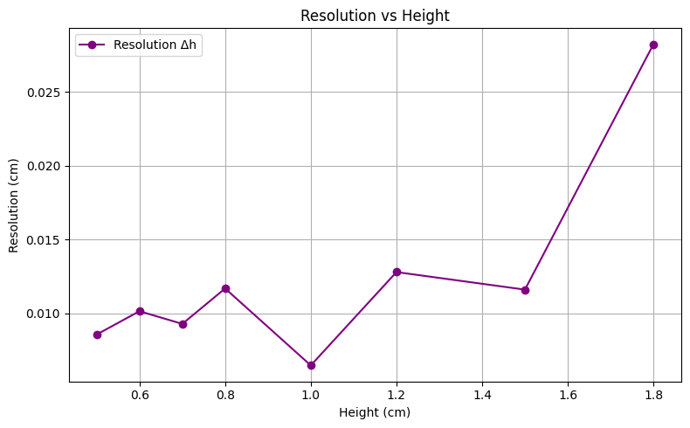

Fig. 8. Resolution VS Height

In conclusion, the sensor's empirical resolution is 0.1 cm, based on the experimental step size. However, calculated resolution varies with height due to changes in sensitivity. The best resolution of 0.0065 cm is observed near 1.0 cm, while it degrades significantly at 1.8 cm. This emphasizes that the sensor performs best in the central height range.

*E. Accuracy*

Accuracy was determined by comparing the measured sensor outputs to the expected values given by the theoretical model. Theoretical Model Include the model equation that describes the theoretical relationship between height (h) and output voltage (Vout) ,

A:   70840.3588        B:    42.3284          C:  54.9725

This model was derived from theoretical considerations and used as the reference for accuracy evaluation.

Error = $V_{measured}$- $V_{theoretical}$

Relative Error (%) = $\frac{V_{measured} - V_{theoretical}}{V_{theoretical} }$ x 100%

Accuracy (%) = 100% - Relative Error%

$$RMSE= \sqrt{mean({(V_{measured} - V_{theoretical})}^{2})}$$

RMSE $→$ Root Mean Square Error

$$MAPE=mean(Relative Error Percent)$$

MAPE $→$ Mean Absolute Percentage Error

$mean accuracy \%=mean(Accuracy\%)$

Theoretical Model Include the model equation that describes the theoretical relationship between height (h) and output voltage (Vout):

 A:   70840.3588        B:    42.3284          C:  54.9725

This model was derived from theoretical considerations and used as the reference for accuracy evaluation.

TABLE VI. ACCURACY FOR EACH HEIGHT

|  |  |  |  |  |
| --- | --- | --- | --- | --- |
| Height  (cm) | Average Voltage(mV) | Expected Voltage(mV) | Abs. Error  (mV) | Accuracy(%) |
| 0.5 | 942.0 | 930.44 | 11.56 | 98.76 |
| 0.6 | 890.0 | 881.43 | 8.57 | 99.03 |
| 0.7 | 828.8 | 837.33 | 8.53 | 98.98 |
| 0.8 | 796.3 | 797.44 | 1.14 | 99.86 |
| 1.0 | 707.4 | 728.05 | 20.65 | 97.16 |
| 1.2 | 647.6 | 669.78 | 22.18 | 96.69 |
| 1.5 | 607.6 | 597.99 | 9.61 | 98.39 |
| 1.8 | 565.8 | 540.09 | 25.71 | 95.24 |

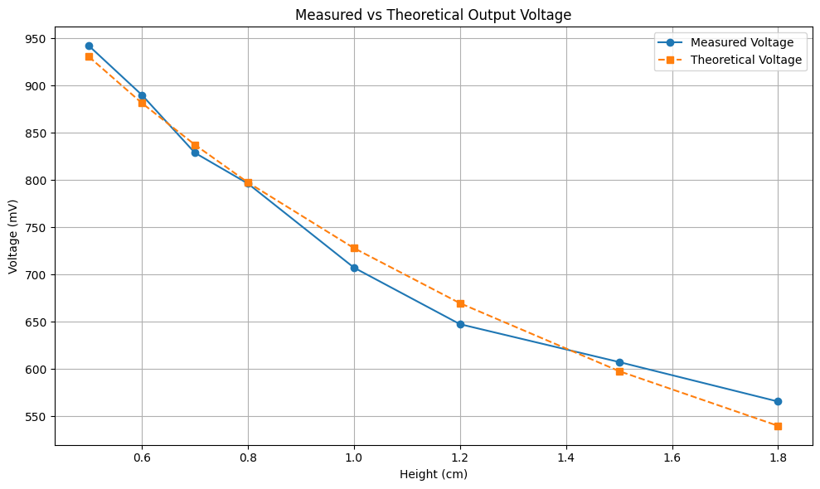

Fig. 9. MEASURED VS THEORETICAL OUTPUT VOLTAGE

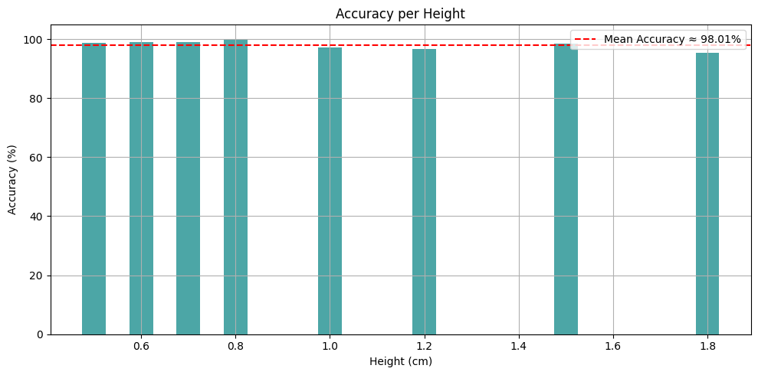

Fig. 10. ACCURACY PER HEIGHT

Based on comparison between measured voltages and theoretical values at discrete heights:

TABLE VII. SUMMARY OF METRICS

|  |  |
| --- | --- |
| Metric | Value |
| Root Mean Square Error (RMSE) | ≈ 15.63 mV |
| Mean Absolute Percentage Error (MAPE) | ≈ 1.99% |
| Mean Accuracy | ≈ 98.01% |

The sensor exhibited an average accuracy of 98.01% across the tested range (0.5 cm to 1.8 cm). Accuracy tended to maintain almost constant value across the heights . RMSE of 15.63 mV indicates low variance from the theoretical model. These values can be improved through calibration or noise filtering

The sensor demonstrated a mean accuracy of approximately 98.01% compared to the theoretical response curve.

Conclusion for Accuracy:

The sensor demonstrates high accuracy with a mean of ~98.01% and low RMSE (15.63 mV). Deviations are minimal across the entire operating range, with the highest mismatch occurring at the upper end (1.8 cm). The accuracy analysis validates the reliability of the theoretical model and confirms strong agreement between expected and experimental values.

*F. Linearity*

**Linearity** describes how closely the sensor's actual output follows the theoretical model it's supposed to match. It's about how well the real sensor response matches the expected equation,

$V_{out}=\frac{A}{Bh+C}$

across the whole range.

Linearity Error (%) = $\frac{V_{measured} - V_{fit}}{V_{max}- V_{min} }$ x 100%

Vmeaured(h) = actual voltage at height h

Vfit(h) = model prediction at that height

Vmax and Vmin = max and min voltages from your measurements.

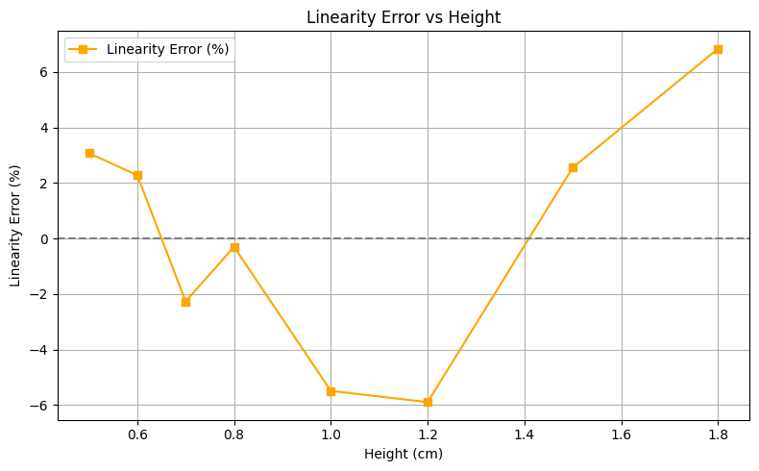

Fig. 11. LINEARITY ERROR VS HEIGHT

Height = 0.5 cm => Linearity Error ≈ 3.07 %

Height = 0.6 cm => Linearity Error ≈ 2.28 %

Height = 0.7 cm => Linearity Error ≈ -2.27 %

Height = 0.8 cm => Linearity Error ≈ -0.30 %

Height = 1.0 cm => Linearity Error ≈ -5.49 %

Height = 1.2 cm => Linearity Error ≈ -5.90 %

Height = 1.5 cm => Linearity Error ≈ 2.56 %

Height = 1.8 cm => Linearity Error ≈ 6.83 %

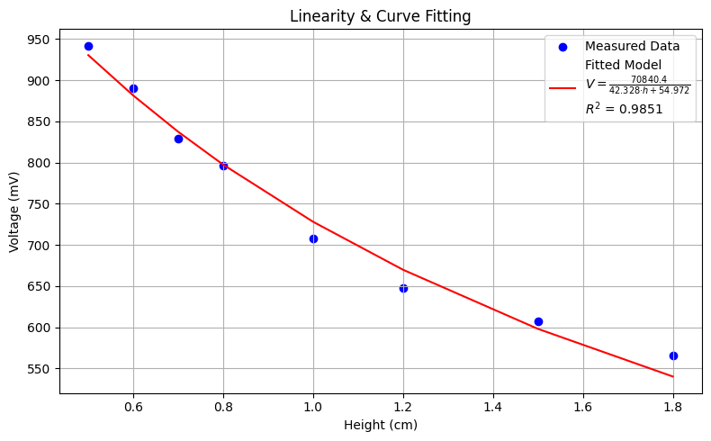

Fig. 12. : GOODNESS OF THE FIT($R^{2}$)

Fitted Parameters: A = 70840.359, B = 42.328, C = 54.972

R² (Goodness of Fit): 0.9851

TABLE VIII. Linearity Error

|  |  |
| --- | --- |
| **Height (cm)** | **Linearity Error (%)** |
| 0.5 | +3.07 |
| 0.6 | +2.28 |
| 0.7 | −2.27 |
| 0.8 | −0.30 |
| 1.0 | −5.49 |
| 1.2 | −5.90 |
| 1.5 | +2.56 |
| 1.8 | +6.83 |

The sensor exhibits a nonlinear response as expected, with maximum linearity error of 6.83% at 1.8 cm. However, the model fits the measured data excellently, with R² = 0.9851. The linearity error remains within acceptable limits for many practical applications in the central operating range

*F. General Conclusion*

This experimental study thoroughly evaluated the performance characteristics of the capacitive level sensor across a height range of 0.5 cm to 1.8 cm. The sensor's output behavior was modeled using the theoretical expression:

$$V_{out}=\frac{A}{Bh+C}$$

with A=70840.36,B=42.33 and C=54.97

which showed a strong fit to measured data (R² ≈ 0.9851), validating its applicability for height-to-voltage conversion.

The following key performance metrics were analyzed:

* Sensitivity: Highest near h ≈ 0.65 cm (≈ –612 mV/cm), tapering off at larger heights. The theoretical sensitivity curve and experimental data matched closely.
* Hysteresis: Maximum loop area ≈ 142.2 mV·cm; error remained below 7% for all tested heights, indicating minimal lag during rising/falling cycles.
* Linearity: The model captured most of the system’s nonlinearity. Maximum deviation occurred around mid-range heights, but remained within ±7%.
* Resolution: Minimum resolution achieved ≈ 0.0065 cm, suggesting the sensor can distinguish sub-millimeter changes in fluid height under ideal conditions.
* Repeatability: Low standard deviation values (≈6.47 mV to 15.56 mV) and error under 4% across all heights demonstrate consistent performance.
* Confidence Intervals: 99% CI bands showed that the measurements had a narrow spread and high reliability.
* Accuracy: With a Mean Accuracy of ≈ 98.01% and RMSE ≈ 15.63 mV, the sensor tracks the theoretical output reliably across the entire range.

Iv RESULTS

*A. Observations*

TABLE IX. . VARIATION OF THE OUTPUT VOLTAGE WITH HEIGHT

|  |  |  |  |  |  |
| --- | --- | --- | --- | --- | --- |
| **Height (cm)** | **Voltage Reading (mV)** | | | | |
| ***Set 1*** | ***Set 2*** | ***Set 3*** | ***Set 4*** | ***Set 5*** |
| 0.5 | 958 | 960 | 952 | 960 | 940 |
| 0.6 | 902 | 900 | 904 | 896 | 909 |
| 0.7 | 837 | 835 | 847 | 841 | 833 |
| 0.8 | 801 | 805 | 813 | 819 | 803 |
| 1.0 | 714 | 716 | 712 | 708 | 726 |
| 1.2 | 667 | 653 | 651 | 649 | 655 |
| 1.5 | 613 | 609 | 615 | 611 | 621 |
| 1.8 | 574 | 576 | 584 | 590 | 570 |

B. Input-output characteristic graph

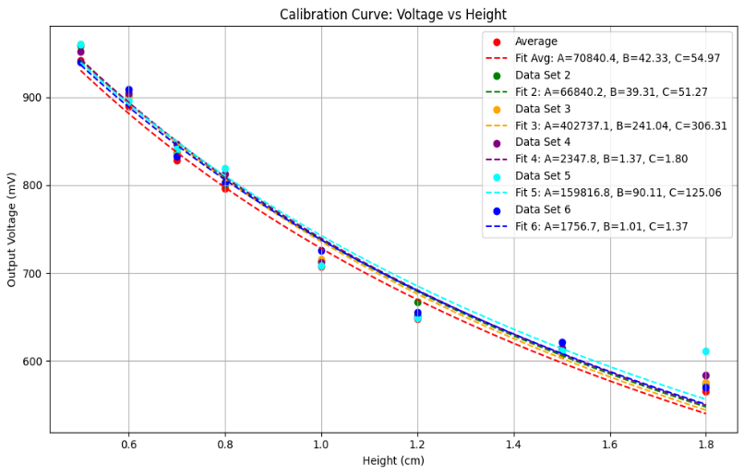

Fig. 13. Variation of Voltage VS Height

V DISCUSSION

## Difficulties

*1)* *Reducing the effect of stray capacitance:* Unintentional capacitance that develops between adjacent wires or components is known as stray capacitance. It may occur  between cables, sensor traces, and ground, or between parts and other surrounding objects. To minimize stray capacitance, the traces between the capacitor and resistor were kept as short as possible, and we also ensured that nearby metal objects or floating copper fills were either grounded or removed.

*2)* *Obtaining a fixed overlapping area between the plates:* At first, two plates with similar areas were used. But it was difficult to make the contact area constant. Therefore, a copper plate with a larger area was used as the upper plate of the capacitor and a plate with a smaller area was used as the lower plate of the capacitor. By this method, we ensured that regardless of small lateral shifts or misalignment, the entire area of the lower plate was always covered. Hence a constant effective area was obtained.

*3)* *Reduction of the electrical noise:* Electrical noise refers to unwanted signals or interference that can affect the performance of the circuit. A passive high-pass filter was used to block low-frequency noises such as power line hum(50Hz) and low-frequency interference from other electronic devices. Since crocodile clips were used to connect the plates to the circuit, As the clips might come in contact with the circuit, they can cause transient voltage spikes or fluctuations, leading to instability in the circuit. To avoid these fluctuations proper connections were used in the circuit.

*4)* *Material Limitations:* Copper plates might oxidize over time, altering their electrical properties and affecting long-term reliability. Also, since copper is conductive, any direct contact could induce unwanted current paths.

## Strengths

*1) Simple and Cost effective:* The circuit consists of a capacitor, resistor and a passive high-pass filter, all of  which are easy to find and made from low-cost materials

*2) Contactless operation:* Capacitive sensors do not require direct physical contact to detect changes in the height between parallel plates of the sensor arrangement.Therefore, this reduces the mechanical wear and tear.

*3) Low power consumption:* Typically consumes very little power, which is suitable for low-power systems.

*4)* *Customizable design:* By adjusting the capacitor plates or capacitor values, sensor can be designed to obtain various sensitivities, distances.

## Weaknesses

*1) Sensitivity to environmental conditions:* Sensor can be sensitive to environmental conditions such as temperature, humidity, and electromagnetic interference. Variations in these factors can change the dielectric properties of the air leading to inaccurate measurements.

*2)* *Mechanical instability:* Small vibrations, changes in pressure, or misalignments can result in instability leading to false measurements.

*3)* *Limited resolution for small height differences:* The precision of a parallel plate capacitor with macroscopic copper plates might be insufficient to identify subtle height changes(ridges and valleys) without extremely sensitive equipment.

## Comparison

The capacitive sensor, based on varying plate distance and a high-pass filter setup, offers a unique design with a customizable capacitance range and sensitivity. It works well for basic applications, offering quick and reliable sensing over a short range. However, compared to more sophisticated sensors, it may require more frequent calibration and can process slower response time.

CONCLUSION

As the initial step of the capacitive-based fingerprint sensor we successfully developed a sensor that can detect height differences. With further improvements in the future, we are planning to identify the valleys and ridges in the fingerprint. By utilizing a parallel plate capacitor with copper plates and air as the dielectric medium, combined with a high pass filter to eliminate low-frequency noise, the sensor effectively measured voltage variations across a resistor connected in series with the parallel plate capacitor and it was displayed on the oscilloscope for measurements. The calibration using structures of varying heights provided valuable insights into the sensor's sensitivity and accuracy, laying a solid foundation for further refinement and optimization in identifying complex fingerprint patterns .

This project delivered technical insights into signal  processing and noise reduction, demonstrated scalability for future adaptations, and also provided valuable experience in sensor design and calibration.

##### Acknowledgment

Our profound appreciation is extended to Dr.R.M.R.D.B Ranaweera, Dr. Tharindu Weerakoon, Dr. Nalin Harischandra for their tremendous support and guidance throughout the project. Additionally, we are grateful to our department’s technical staff and laboratory assistants for providing the necessary equipment for the project. We also want to express our gratitude to our fellow batchmates for the incredible support. Any errors in this work are entirely our fault and should not be interpreted as a reflection of the efforts of those who helped us.

##### References

1. *J.-M. Nam, S.-M. Jung, and M.-K. Lee, “Design and implementation of a capacitive fingerprint sensor circuit in CMOS technology,” Sensors and Actuators A: Physical, vol. 135, no. 1, pp. 283–291, Mar.2007,doi: https://doi.org/10.1016/j.sna.2006.07.009.)*
2. H. Nishiyama and M. Nakamura, “Form and capacitance of parallel-plate capacitors,” *IEEE Transactions on Components, Packaging, and Manufacturing Technology: Part A*, vol. 17, no. 3, pp. 477–484, 1994, doi: <https://doi.org/10.1109/95.311759>
3. O. Samarakoon, “Sensor Calibration Analysis,” GitHub, Apr. 2025. [Online]. Available: <https://github.com/Oshadha345/Sensor-Calibration-Analysis>